psychology DEPARTMENT Research Participant Pool guidelines

SUMMER 2025
COORDINATOR Xiaobin Lou | rp@uga.edu |website

RESEARCH PARTICIPATION REQUIREMENT

For Summer 2025, you’ll need to complete a total of 6.5 hours of research credit by the end of the session. You can complete these credits through in person studies, online, or a combination of in-person and online offerings. Because of the potentially limited number of in-person studies offered during the summer, participants can earn all of their credits online which is different than expectations for the Fall and Spring semesters. However, to incentivize in-person offerings, participants will earn an additional .5 credits for in-person studies. For example, a participant would earn 1 credit for a 30 minute in-person study compared to only .5 credit for a 30 minute online study. Participants are not required to complete any online studies – all research credits can be earned through in-person or virtual interactive study participation. All research pool participation is to be completed by 5pm on July 1st (Summer Session 1) and July 29th (Thru Term).

There are several ways for you to earn credit (described in more detail in the following pages):

In-Person
- Participate in typical in-person studies conducted by the Psychology Department at the University of Georgia with appointments available via the SONA System
Virtual Interactive
- Participate in virtual interactive studies (e.g., live video conference session with a researcher; daily diary studies with daily or weekly surveys) conducted by researchers in the UGA Psychology Department with appointments available via the SONA System
- Attend specified virtual talks (1 credit per 1 hour of attendance). These opportunities will be limited. If available, they will be posted in the SONA System.
- Research alternatives
  - Conduct a guided review of an empirical psychology article (1 review = 1 credit). These will be posted on the SONA system (not counted towards the online credit max).
  - Participate in online pseudo-studies. These are inactive research studies in which participant data will not be analyzed (30 minutes of a pseudo-study = 0.5 credits). These will be posted on the SONA system.
Online
- Participate in online studies conducted by the Psychology Department at the University of Georgia via the SONA System
Sona Screener (all participants)
- Participants will complete a screener survey when they first login to the system which will count towards the 6.5 credit requirement (0.5 credits)

SUMMER SESSION 1 (Cyterski)
RP POOL OPENS ON June 6th, 2025, AT 8 AM
RP POOL CLOSES ON July 1st, 2025, AT 5 PM

THRU TERM (Brisson/
Morris)
RP POOL OPENS ON June 6th, 2025, AT 8 AM
RP POOL CLOSES ON July 29th, 2025, AT 5 PM

**If participants have concerns about accruing their 6.5 credits, they can email rp@uga.edu to develop a plan to complete the requirements. Examples of situations that may be accommodated include (but are not limited to): participants with demanding work or lab schedules that limit availability to participate in studies scheduled during typical business hours or participants who are under the age of 18.

LOGGING INTO YOUR SONA SYSTEMS ACCOUNT
Your SONA SYSTEMS account will be created for you using your UGA e-mail address. You will receive log in information for your account on or around the first day of class.
On this website, you can sign up for lab studies, find talks to attend, and find how to complete your research reviews and/or pseudo studies. You can also view your lab study appointments and check the number of credits you have earned.
TO ACCESS THE SITE
Go to http://uga.sona-systems.com
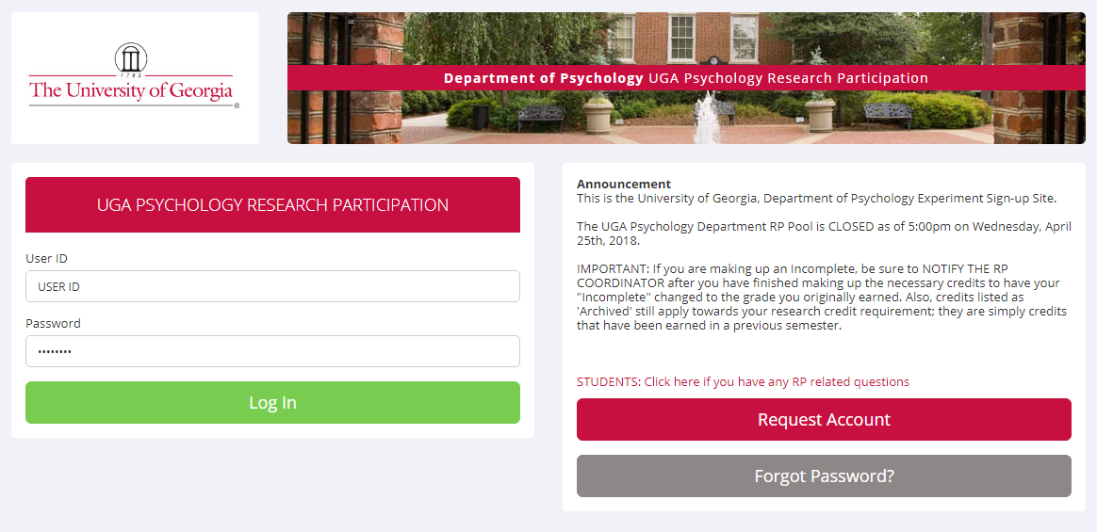
Make sure you are on the Psychology Department’s Sona Systems website – they all look similar, so check on the front page for “UGA Psychology Research Participation” banners. This is what the first screen will look like:

Use the Log In information you receive to log in. Please log in within 3 days of receiving this information to confirm your account.
Note that Sona will add the “@uga.edu” for you, so don’t enter this information when entering your email address

SIGNING UP FOR STUDIES
Go to http://uga.sona-systems.com
Log in using your Sona Systems account login information
Under “Study Sign-Up” click “View available studies”
There will be a list of all available studies and research alternatives. Explore the opportunities by clicking on the titles to read a detailed description of what the researcher is expecting from participants. There will also be information about how long the study will take and how many credits each study is worth.
Check the eligibility requirements to make sure you are eligible to participate in the study – just because you can sign up for the study on Sona does not guarantee eligibility. Researchers have the right to deny participation to interested students based on posted eligibility criteria.
If you are interested in participating and eligible to participate, click “Timeslots Available” then “View Timeslots for this Study” to see a list of available times the study is running.
Select the timeslot you would like to participate in and then click “Sign Up” to officially sign up for the study.
After completion of a study, the researcher will grant you credit on Sona Systems. You will be able to check your accumulated credits on your account any time. Researchers who are hosting online lab studies may set their own deadline as long as it is on or before the RP Pool closing date and time.

PARTICIPATING IN RESEARCH STUDIES

Participate in studies conducted by the Psychology Department at the University of Georgia via the SONA System. Pay close attention to the study description to determine if the study is classified as in-person, virtual interactive, or an online survey.
ATTENDING SPECIFIED PSYCHOLOGICAL RESEARCH TALKS

If offered throughout the semester, options to attend academic talks in person or virtually may become available on Sona. You will sign up to attend these talks just as you would to complete a research study. Each talk posted will have a description, time, and location. At the talk, there will be a person recording attendance (named on Sona). In person, you will need to check in with that person when you arrive for the talk. For virtual talks, that person will check the attendance list of the talks at the beginning and end of talk. You are expected to stay both in person and online for the duration of the talk. You will receive credit for attending the talk through Sona, just as you would for attending a talk.

Please note that if you do not attend a talk for which you have signed up, you will receive an Unexcused Absence.

RESEARCH ALTERNATIVE: REVIEWING PSYCHOLOGICAL PAPERS (not counted towards online credit max)

Article reviews are posted on Sona. The Sona description will provide instructions for how to complete the article review.

The purpose of having the option to complete a review paper is for the people who do not want to participate in studies may also complete some in-depth reading and reflection about psychological research beyond the coverage in a textbook.
These links on Sona will walk you through an entire empirical article, asking you read and reflect on the abstract, introduction, methods, results, and discussion. After each section, you will answer a few questions about the paper. Questions will be timed to guarantee you are completing the task thoroughly.
Inappropriate or incomplete responses will need to be resubmitted or be accepted for less credit. NOTE: Any answers that is entirely or partly copied word-for-word from another source (or from another student) are not acceptable. This is plagiarism, which is a very serious academic offense. Your instructor may also be contacted to determine if any additional steps should be taken to deal with academic dishonesty.

RESEARCH ALTERNATIVE: PSEUDO-STUDIES
Pseudo-studies are posted on Sona. Follow the direct link in the description to complete the study.
These opportunities are old research studies that are no longer active in which participant data will not be analyzed. Pseudo-studies are a great option for students who are interested in participating in research but may be too young to do so, or do not feel comfortable providing data for typical research studies.
CREDITS FOR RESEARCH ALTERNATIVE OPTIONS
Research alternative submissions (guided article reviews and pseudo studies) are graded by the Research Pool Coordinator (RP Coordinator). The RP Coordinator typically reviews submissions and awards credit on a biweekly basis. Once the submission is reviewed, the Sona timeslot will be changed from “credit pending” to either marked as “credit granted” or “excused absence.” Toward the end of the semester, when the submission frequency increases, expect it to take longer for your submissions to be reviewed and credit granted. Do not email the RP Coordinator to check on the status of your submission.
Once all study and non-study (research alternative) credits are granted, the RP Coordinator will notify all participants via email. Within this email, will include clear instructions for how to dispute a credit that you think was missed (i.e., you were marked as absent when you believe credit should have been awarded). Only requests that come via the survey link in this email will be reviewed. All participants will have 24 hours after the link is sent to complete the form before it is disabled. The RP Coordinator will review all submissions and correct any errors if necessary before sending final credit reports to instructors.
INCOMPLETES

Final credit reports will be emailed to instructors by July 6th (Summer Session 1) and August 3rd (Thru Term) at 8:00am. After this time, no credits will be changed in the Sona system.
IF YOU DO NOT EARN THE TOTAL NUMBER OF RESEARCH CREDITS THAT ARE REQUIRED FOR YOUR COURSE BY THE CLOSING DATE OF THE RP POOL, THIS WILL RESULT IN A REDUCTION OF YOUR FINAL GRADE FOR THE COURSE BY ONE LETTER.

**If participants have concerns about accruing their 6.5 credits, they can email rp@uga.edu to develop a plan to complete the requirements. Examples of situations that may be accommodated include (but are not limited to): participants with demanding work or lab schedules that limit availability to participate in studies scheduled during typical business hours or participants who are under the age of 18.

